

Analysis Document

[OKI: MergeTool]

Software Division

Evolution

Version: 1.0

1-Nov-2015

486 & 487, Udyog Vihar Phase-III

**Gurgaon- 122016, India**

|  |  |  |  |
| --- | --- | --- | --- |
| **Document Control** | | | |
| **Reference No.** |  | | |
| **Document Name** | User Guide Document [OKI: MergeTool] | | |
| **Version No.** | 1.0 | | |
| **Document Status** | Draft | | |
| **Issue Date** | 01-Nov-2015 | | |
| **Compliance Status** |  | | |
| **Review Period** |  | | |
| **Security Classification** | Restricted | | |
| **Distribution** |  | | |
|  | **Name** | **Role** | **Signature** |
| **Authored by** | Zaheer | SSE |  |
| **Reviewed by** | Anil Agarwal | Project Manager |  |
| **Approved by** |  |  |  |
| **Released by** |  |  |  |

|  |  |  |
| --- | --- | --- |
| Document Revision History | | |
| Version | Release Date | Change Description |
| 1.0 | 01-Nov-2015 | Initial Draft |
|  |  |  |
|  |  |  |
|  |  |  |
|  |  |  |
|  |  |  |

Table of Contents

1 Introduction 5

1.1 Objective 5

1.2 Scope 5

2 Home page 7

2.1 Overview 7

3 DataMerge 7

3.1 Overview 7

4 Searches 9

4.1 Searches with Country. 9

4.2 Searches with Name and Country. 9

4.3 Searches with Id, Key, Name and Country. 9

4.4 10

5 Validation Rules 11

5.1 Diff Vat No or Countries 11

5.2 Cannot merge into null Vat No. 12

5.3 Can merge from null Vat No to null Vat No. 12

6 Refresh 13

1. Introduction

This document describes the process and steps of the application and their rules which are using in this application. This document serves the how the different Pages are involved in the project. The prime intention of this analysis is to create the understanding about the business implementation of the Merge tool application. Like merge one customer group to another customer group with few validation rules and their respective source tables as well as finding out impacts/effects in the application and its related tables.

* 1. Objective

To develop the business understanding and low level implementation of the Mergetool as well as changes impact in the project due to different tables and their relationships.

* 1. Scope

This document is intended to provide detail information about the different customers with their customer group’s tables used to merge one customer group to another customer group table with validation message rules.

Select and Merge Record

Does Vat or Country diff

No then Merge

Yes then fail

Pa

If A has a VAT Number and Customer B has NULL VAT Number

Yes then Merge

No then fail

If A has Null VAT Number and Customer B has NULL

No then fail

Yes then Merge

If rule are valid then success message and merge records

1. Home page
   1. Overview

The primary objective of this screen is to show the home page with link button like Home, Tool and Contact.

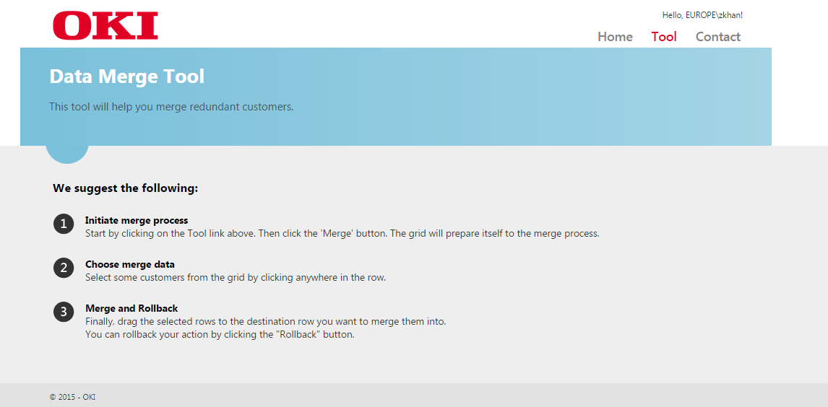

Fig: Home page screen.

1. DataMerge
   1. Overview

AfterClick on Tool link button. Data Merge Tool page will be open. This is the main screen where user can merge with select the checkbox one or more than one customer(s) at least 2 customers have to select one customer group into another customer group.

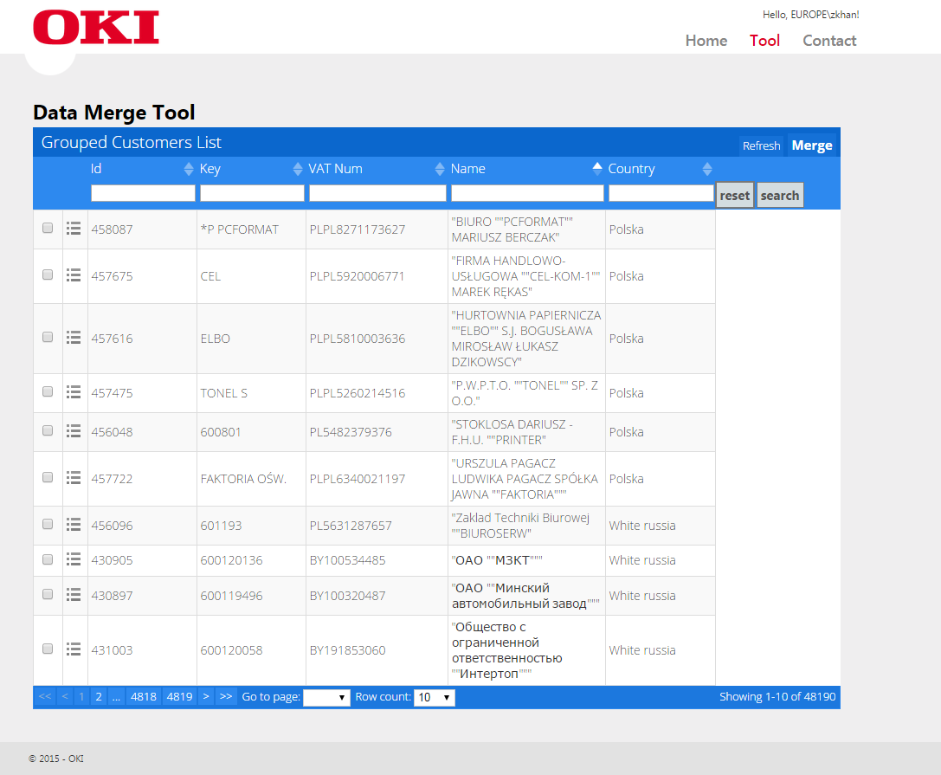

Fig: Merge Tool page screen.

1. Searches

In the Search functionality, user can search with Id, Key, VAT Num, Name and Country. On click Search button.

* 1. Searches with Country.

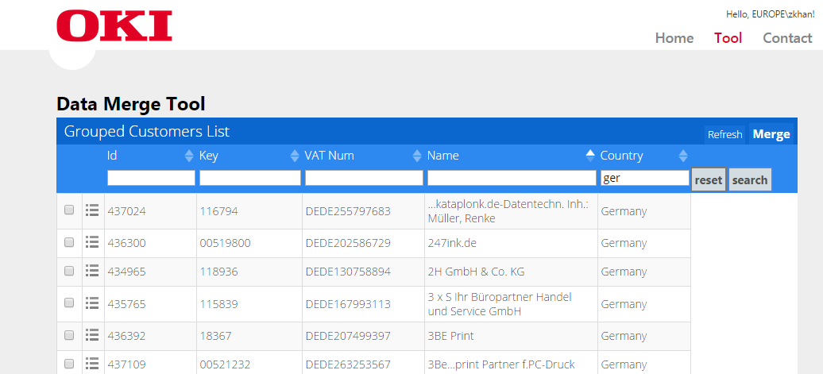

Fig: Search with Country.

* 1. Searches with Name and Country.

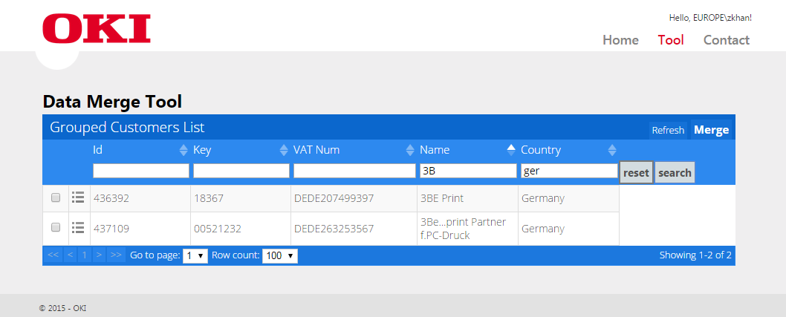

Fig: Search with Name.

* 1. Searches with Id, Key, Name and Country.

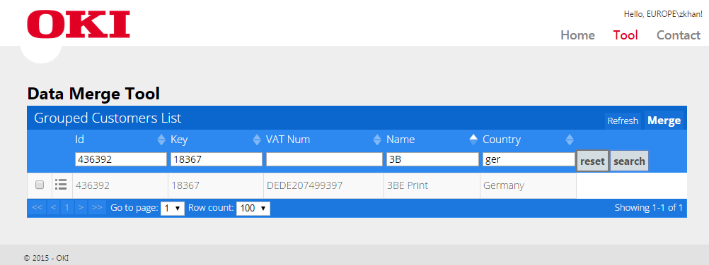



If there is no selected checkbox in the data merge tool screen and click to merge then it will show a message.

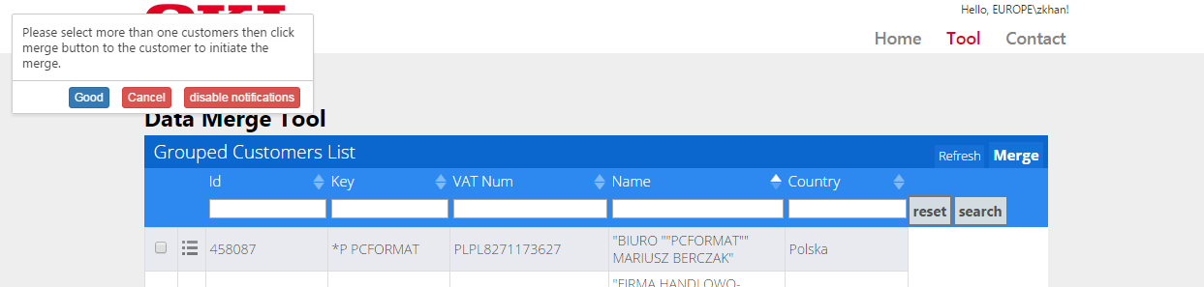

Fig: Message without select any checkbox.

1. Validation Rules
   1. Diff Vat No or Countries

If the customers belong to different countries then they cannot be merged.

If the customers have different VAT Numbers then they cannot be merged.

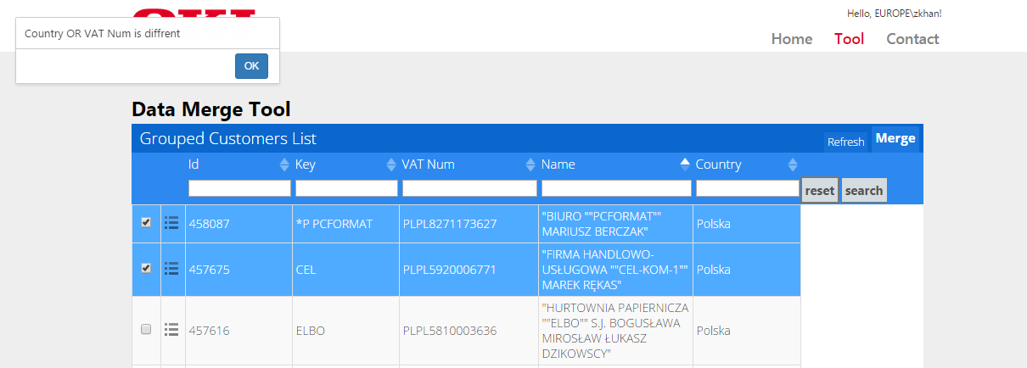

Fig: Message when select diff Vat No.

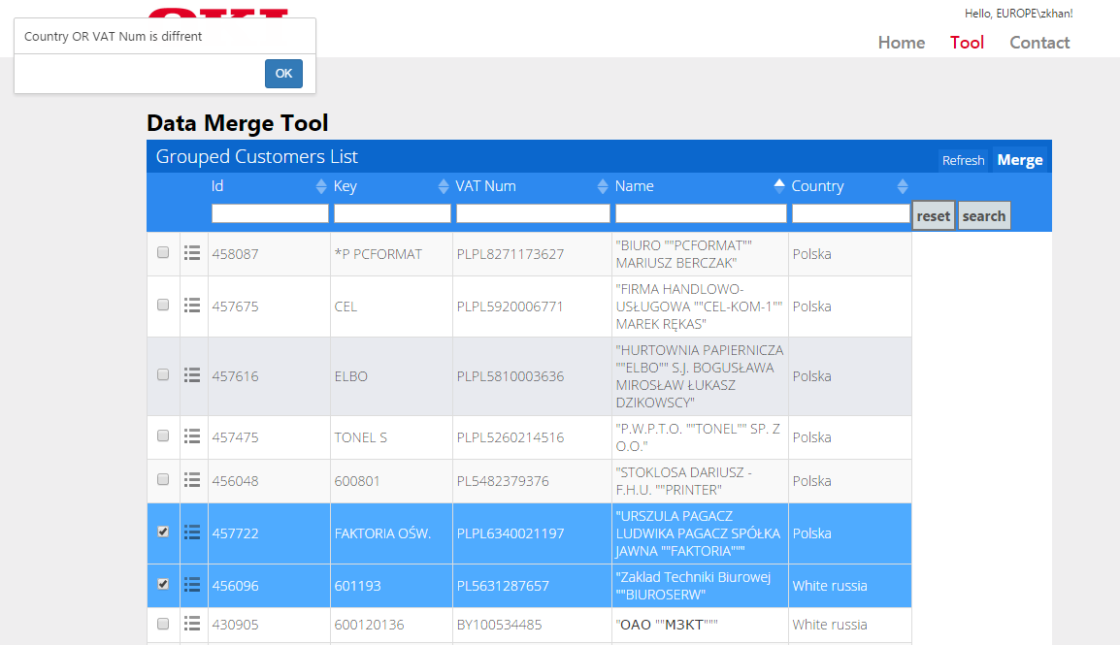

Fig: Message when select diff Vat No or Country.

* 1. Cannot merge into null Vat No.

If Customer A has a VAT Number and Customer B has NULL VAT Number then B can be merged with A

If Customer A has a VAT Number and Customer B has NULL VAT Number than A cannot be merged with B

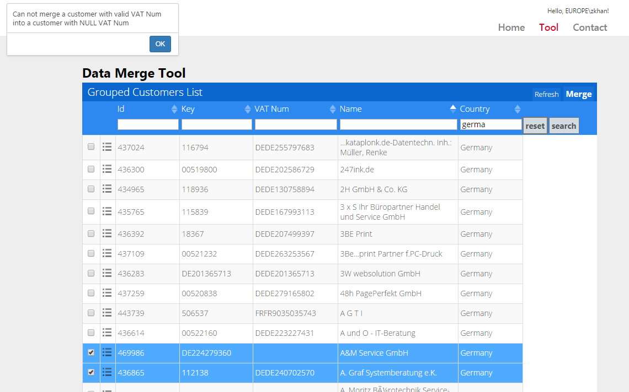

Fig: Message when select diff Vat No or Country.

* 1. Can merge from null Vat No to null Vat No.

Customer A and Customer B both have NULL VAT Number than either can be merged with the other one.

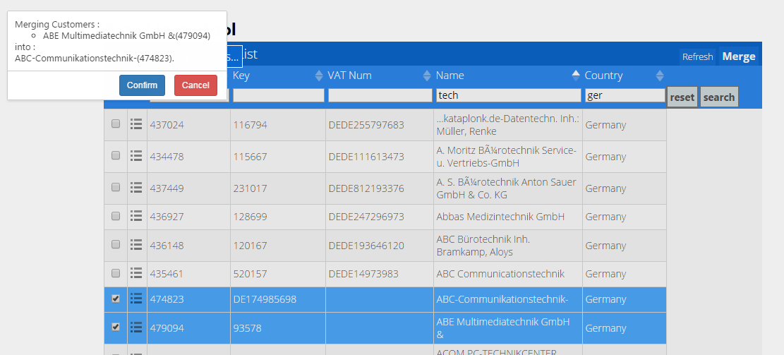

Fig: Confirm Message when select both null Vat No.

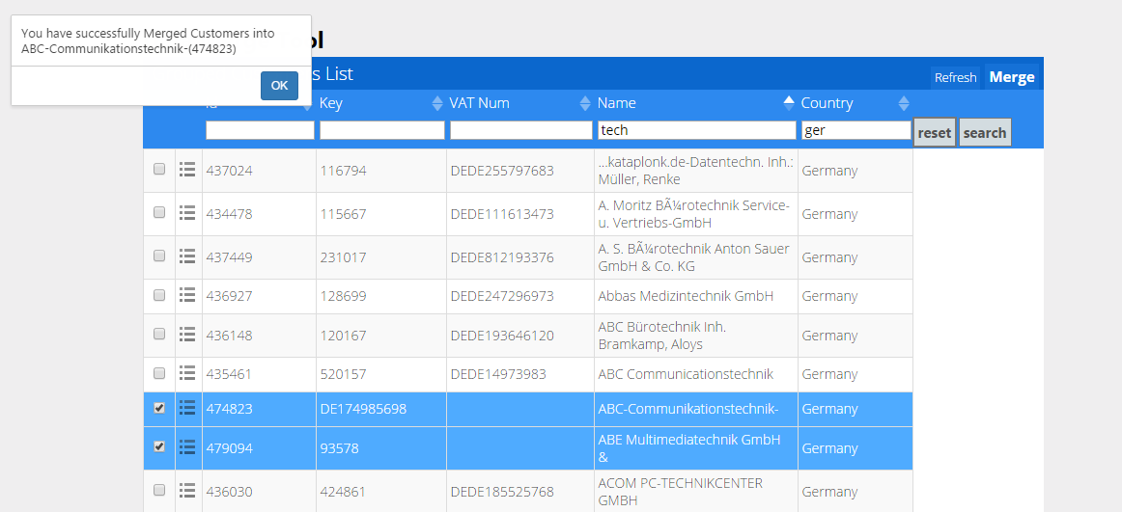

Fig: Success Message when select both null Vat No.

1. Refresh

Refresh button will be refreshing the grid.